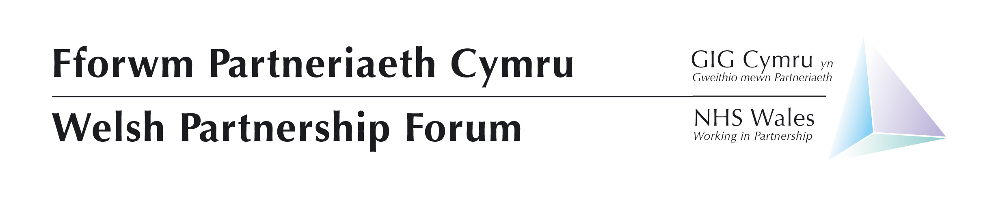
Wednesday 06 July 2022
Cardiff City Stadium
Leckwith Road
Cardiff
CF11 8AZ

Trade union pre-meeting: Captains Lounge 10:15 – 11:15
Employers and Welsh Government pre-meeting: Premier Lounge North 10:30 – 11:15
Full meeting: Premier Lounge North 11:30 – 15:30
Agenda Item No. | Agenda Item | Lead | Style of Report | Doc No. | Start Time | Time allocated
Welcome and Apologies
1 | Judith Paget to chair – include clearing of previous WPF note & actions | Judith Paget | Verbal & Paper | 01.1 | 11:30 | 05 mins
2 | Current Position | Judith Paget | Verbal |  | 11:35 | 10 Mins
Strategic – Items for Discussion
3 | The annual Education & Training Commissioning Plan | Martin Riley and Marie-Claire Griffiths | Presentation |  | 11:45 | 40 mins
4 | Anti-Racist Wales Action Plan | Rebecca Gorman | Link |  | 12:25 | 15 mins
5 | NHS Executive | Judith Paget | Verbal |  | 12:40 | 15 Mins
Lunch – 12:55 – 13:30
6 | The Plan for Planned Care Recovery | Andrew Sallows | Presentation |  | 13:30 | 20 Mins
7 | Workforce to support the Plan Recovery Plan | Helen | Workshop |  | 13:50 | 40 Mins
8 | Health and Social Care Workforce Strategy outcomes | Julie Rogers | Paper | 8.1 & 8.2 | 14:30 | 10 Mins
Business
9 | Staff Survey | Rhiannon Windsor | Verbal |  | 14:40 | 10 Mins
10 | Occupational Health update and workshop | Sara Whittam | Paper and Workshop | 9.1 & 9.2 | 14:50 | 30 mins
NHS Policies and Contracts
11 | General Policy update | Andrew Davies | Paper | 11.1 | 15:20 | 5 mins
For Information
12 | NHS Staff Council Update | Attendees | Verbal |  | 15:25 | 5 Mins
13 | Social Partnership and Fair Work | Amber Courtney | Verbal |  | 15:30 | 5 Mins
14 | Staff Governance Framework | Helen Thomas | Verbal |  | 15:35 | 5 Mins
Any other business
15 | Nothing currently raised. | Judith Paget | Verbal
16 | Future WPF Meetings  - 17 November 2022 | Judith Paget | Verbal

